#### **DFS**

* Idea:
  + similar idea with BFS, but we can use either
    - A stack
    - A recursion
  + Recursive algorithm: we visit a vertex **v**

1. Check all adjacent vertices of **v**
   1. if it’s not been discovered, label the edge “discovery edge”. Visit the new vertex
   2. label the edge that leads us to an already discovered vertex “back edge”
      1. since it *usually* brings us to a closer vertex
      2. the distance difference is unbounded
   * Observations
     + The discovery edges make a spanning tree
     + **d** does not find the shortest path
     + the benefit is: it discovers new vertices very quickly

* The code: use system stack as our workstack (recursion)

|  |  |
| --- | --- |
| 1  2  3  4  5  6  7  8  9  10  11  12  13 | ~~BFS~~DFS(G):  Input: Graph, G  Output: A labeling of the edges on  G as discovery and ~~cross~~ back edges  foreach (Vertex v : G.vertices()):  setLabel(v, UNEXPLORED)  foreach (Edge e : G.edges()):  setLabel(e, UNEXPLORED)  foreach (Vertex v : G.vertices()):  if getLabel(v) == UNEXPLORED:  ~~BFS~~DFS(G, v)  //components++; |

|  |  |
| --- | --- |
| 14  15  16  17  18  19  20  21  22  23  24  25  26  27  28 | ~~BF S~~ DFS(G, v):  ~~Queue q~~  setLabel(v, VISITED)  ~~q.enqueue(v)~~  ~~while !q.empty():~~  ~~v = q.dequeue()~~  foreach (Vertex w : G.adjacent(v)):  if getLabel(w) == UNEXPLORED:  setLabel(v, w, DISCOVERY)  ~~setLabel(w, VISITED)~~  ~~q.enqueue(w)~~  DFS(G, w)  elseif getLabel(v, w) == UNEXPLORED:  setLabel(v, w, ~~CROSS~~ BACK)  // cycleExists = true; |

* Use cases and functionality:
  + Counts the number of components
  + Detects cycles
* Running time:
  + Expect: visit every edge and vertex, so O(n+m)
  + Looking at specific parts of the code:
    - This whole chunk is $O(n×deg(v))$
    - $deg(v)$ is not very informative, but we know that we will have $n×deg(v) = \sum^{n}{}deg(v) =2m ⇒O(2m)$
  + Total running time is $O(n+m)$.
  + This is optimal running time because we know we have to visit every edge and vertex, therefore we cannot do better than $O(n+m)$.
* DFS doesn’t give a unique solution either

### **Minimum Spanning Tree**

* Example:
  + Connect all houses in Urbana with roads
  + Every road has a cost, we want the **min** cost
* **Algorithm:**
  + Input: connected, undirected graph G with edge weights that are additive.
  + Output: A graph G’ with the following properties:
    - G’ is a spanning graph of G
    - G’ is a tree (connected, acyclic graph, with no cycles)
    - G’ has a minimal total weight among all possible spanning trees

#### **Kruskal’s Algorithm**

* Setup
  + Maintain a list of edges sorted by weight in increasing order → min heap
  + Initialize a disjoint set for every vertex
    - If two vertices are in the same upTree, they are connected

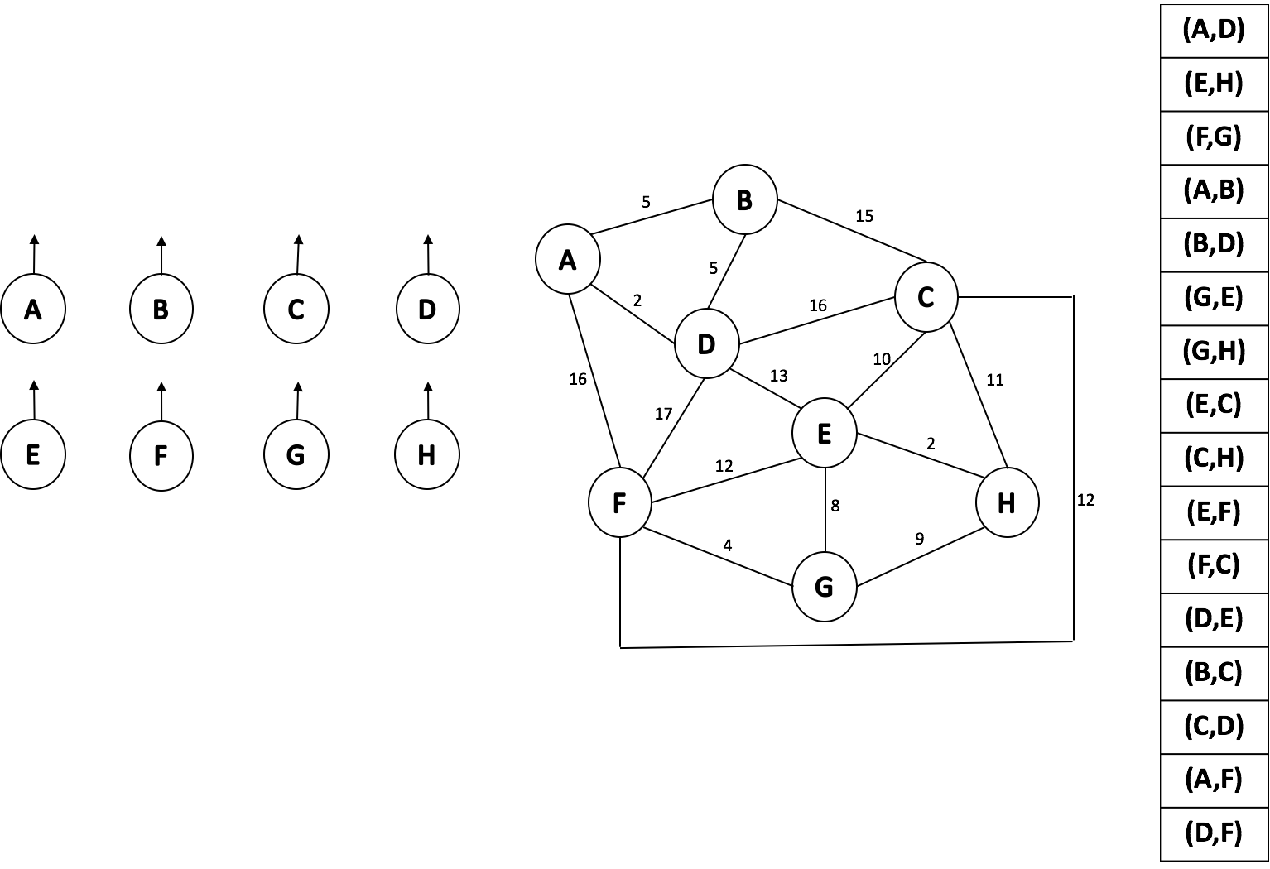

* The code

|  |  |
| --- | --- |
| 1  2  3  4  5  6  7  8  9  10  11  12  13  14  15  16  17  18 | KruskalMST(G):  DisjointSets forest  foreach (Vertex v : G):  forest.makeSet(v)  PriorityQueue Q // min edge weight  foreach (Edge e : G):  Q.insert(e)  Graph T = (V, {})  while |T.edges()| < n-1:  Vertex (u, v) = Q.removeMin()  if forest.find(u) != forest.find(v):  T.addEdge(u, v)  forest.union( forest.find(u),  forest.find(v) )  return T |

* The algorithm logic
  + Take the edge with the smallest weight from the heap
  + If the two endpoints are not already connected
    - add the edge into our spanning tree
    - union the two vertices
  + If they are already connected
    - skip the edge and do nothing, otherwise we create a cycle